Welcome to BioRAFT
Research Management System
The University of Utah Office of Environmental Health and Safety is migrating management and tracking of laboratories and biological research to BioRAFT. BioRAFT is a web-based research management platform that supports laboratory safety compliance. Aside from helping to keep the community safe and reduce accidents, this process is important for the University of Utah to maintain compliance with federal and state laws. Additionally, it helps ensure the institution’s eligibility to apply for federal grants and other financial assistance.
In place of the current system where individual projects are reveiwed and approved by the by the Institutional BioSafety Committee (IBC), in BioRAFT the Principal Investigator (PI) will complete a registration for the laboratory, which will include descriptions of the projects involving biological agents and of the agents and procedures in place to protect laboratory workers. In general after review the lab will be approved for 3 years and then at the end of that period the PI will need to submit a renewal application. If the PI needs to amend their registration (new lab members, new projects, new biological agents, etc) prior to the renewal then this will be performed in BioRAFT. However, the approval date for the registration will remain unchanged meaning that PIs will have only a single renewal cycle to keep track of. Note that currently transgenic/mutant mouse model registrations and human gene therapy registrations will continue to use the paper submission process currently in place until modules for these have been added to BioRAFT.

Here we provide a step by step guide to the registration process. If you have any question about BioRAFT please contact us:
Neil E. Bowles, Ph.D.  Biosafety Officer  Environmental Health and Safety  University of Utah, Bldg. 605  125 South Fort Douglas Blvd  Salt Lake City, UT 84113-5036  801-585-9325  Neil.bowles@ehs.utah.edu | Derek Hedquist  Associate Biosafety Officer  Environmental Health and Safety  University of Utah, Bldg. 605  125 South Fort Douglas Blvd  Salt Lake City, UT 84113-5036  (801) 585-3345  derek.hedquist@ehs.utah.edu
Sophia Gawu
Computer Technician
Environmental Health and Safety
University of Utah, Bldg. 605
125 South Fort Douglas Blvd
Salt Lake City, UT 84113-5036
801-585-5566
sophia.gawu@ehs.utah.edu

- LOGIN: To access BioRAFT please visit: https://utah.bioraft.com
Login by using your University Network ID (uNID) and password

- General Setup Wizard
The first step is to complete the ‘General Laboratory Setup Wizard’. To begin, click the ‘General Setup Wizard’ link.

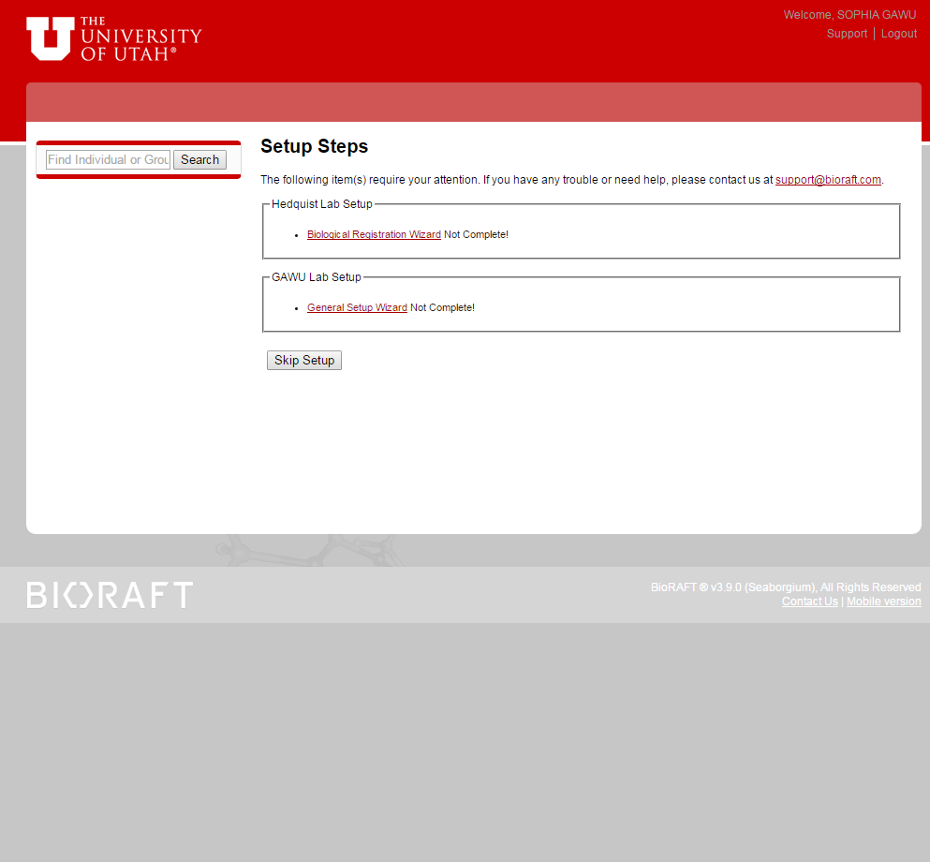

- Laboratory Registration Wizard
Click ‘Continue to Laboratory Setup’. If you prefer that a member of your lab complete this registration and other registrations on your behalf, click the ‘Delegate Now’ link and follow the instructions on the following page. Note some information has been prepopulated by EHS.

- Delegating your Laboratory Registration Wizard
In the ‘Name’ field, begin typing your delegate’s name and select from the pre-populated drop‐down menu. Next, select the appropriate designation from the drop-down menu. Once you have selected your delegate, click ‘Assign’.

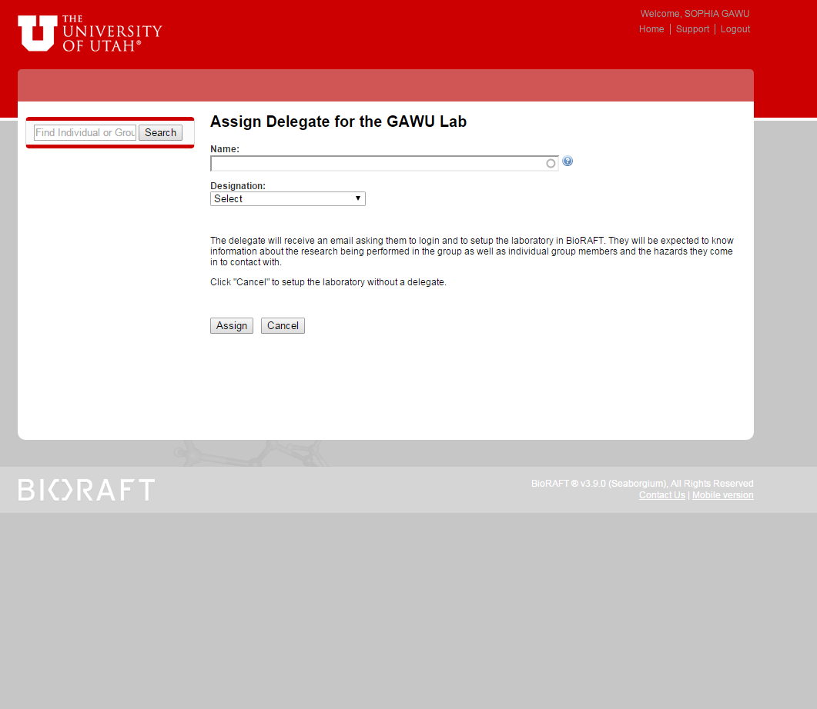

You can either continue working on the Laboratory Registration or assign this to your designee. You can also choose to delegate responsibility for completing the Biological Registration Wizard at this point.

- Enter Lab Contact’s Information
Enter the basic contact information for your laboratory. Then click the ‘Submit’ button at the bottom of the page.
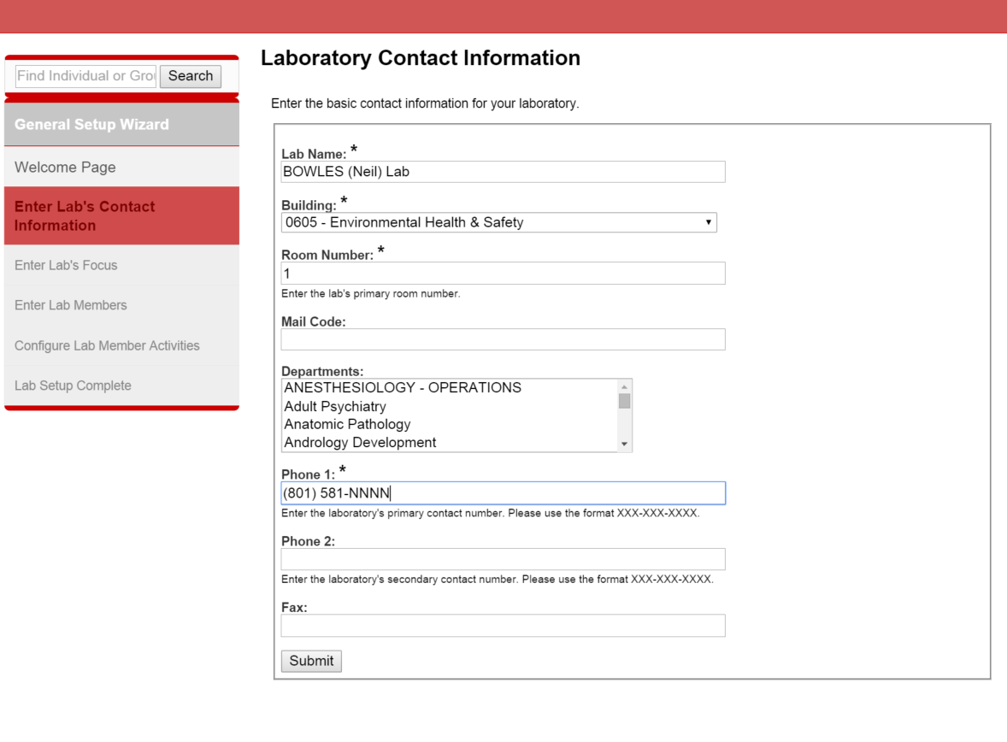

- Enter Lab’s Category and Research Focus

Select the Category of Laboratory that applies to your laboratory(ies): note more than one type category can be selected.

Type a brief summary of your overall research focus and goals in the text box below. Then click the ‘Submit’ button.

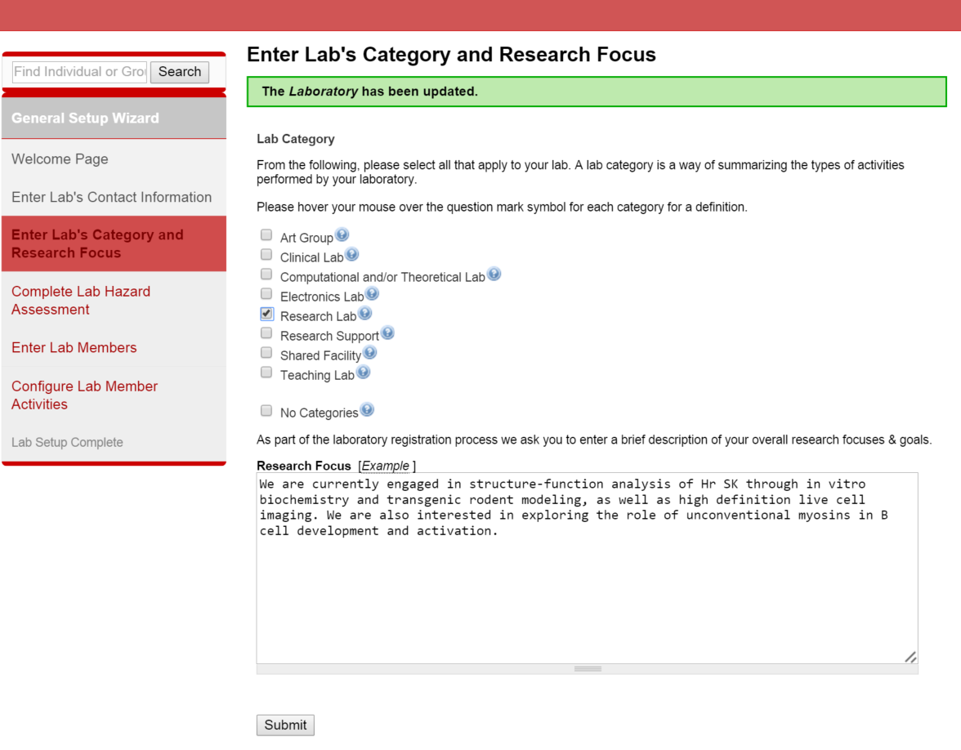
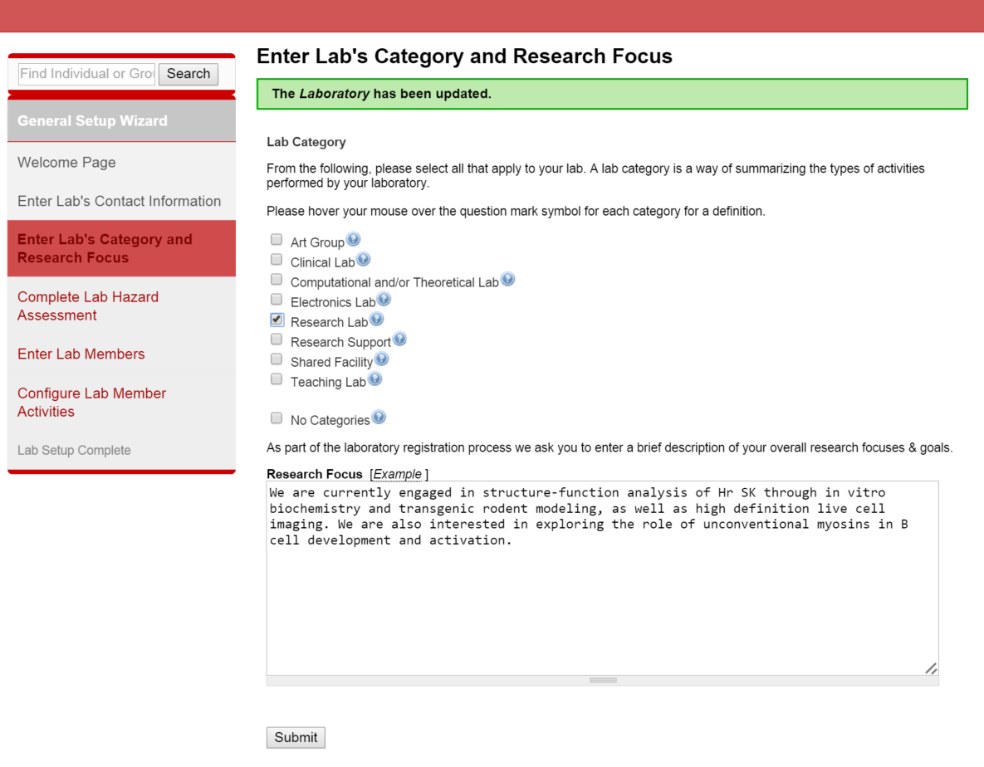
- Complete a Laboratory Hazard Assessment
Please check all boxes that apply. Note that as boxes are checked additional levels may appear that require responses.

If you have no hazards in your laboratory check the “No Hazards” box at the bottom of the page.

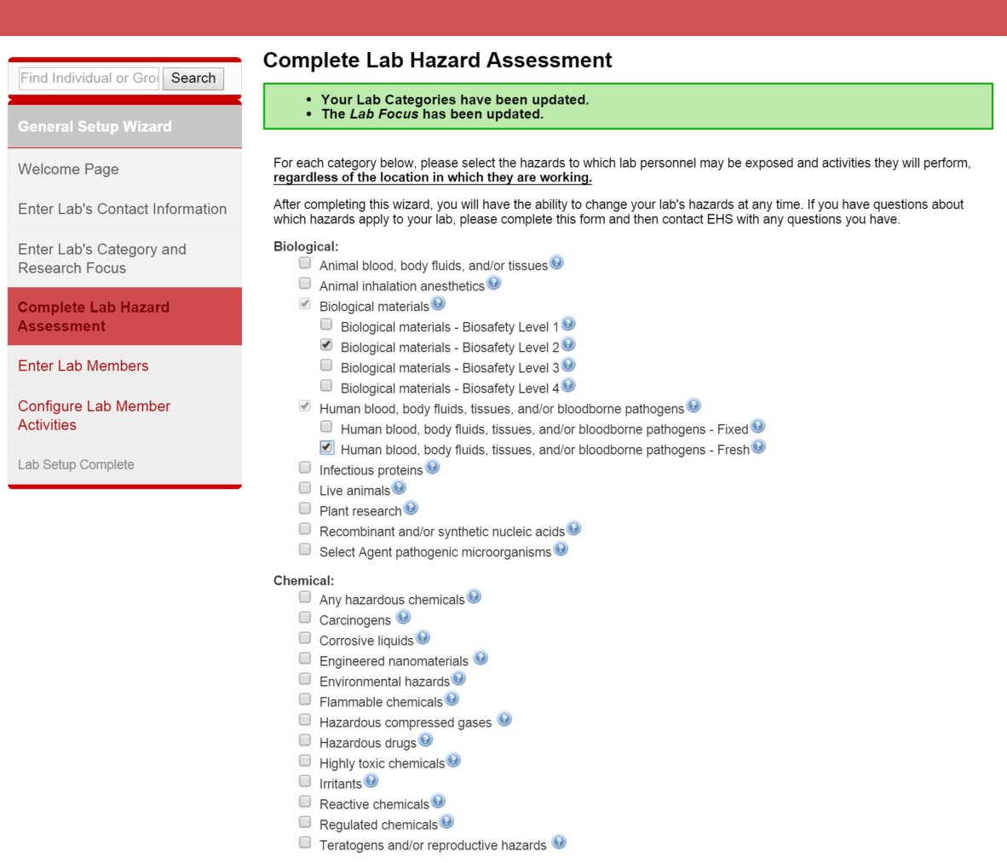
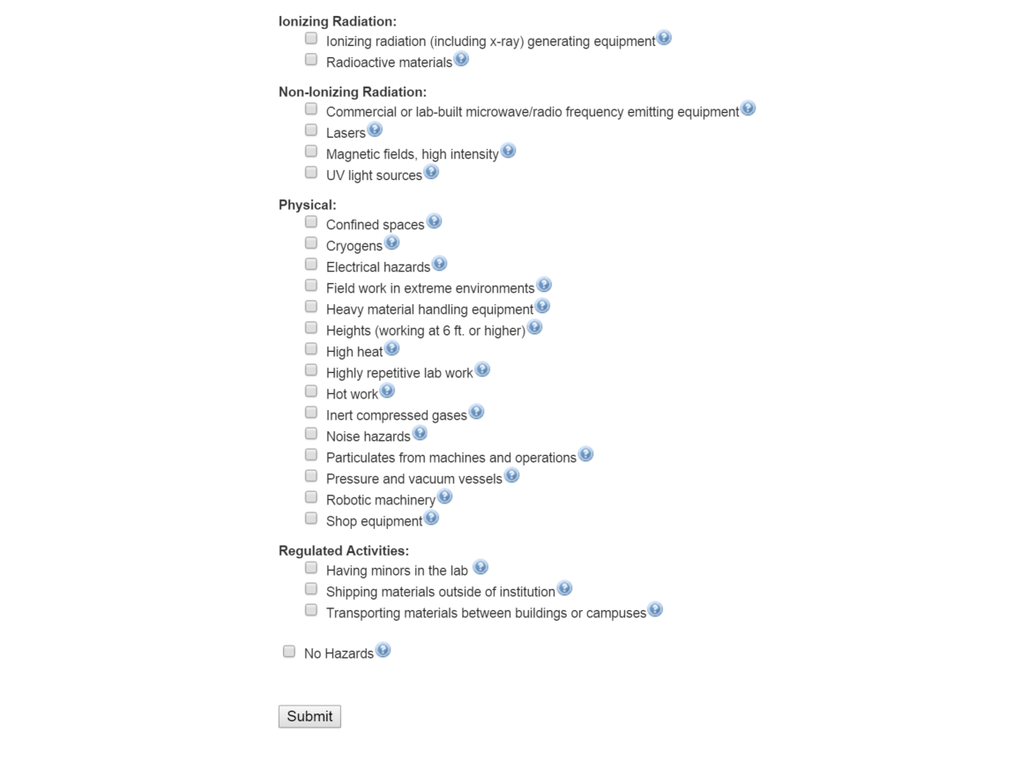

Click on “Submit”

- Enter Lab Members
For all personnel in your lab, begin typing the researcher’s name in the ‘Name’ field and select from the pre-populated drop-down list. Next, select the designation for your researcher from the drop-down. Then click the ‘Lookup / Add’ button.

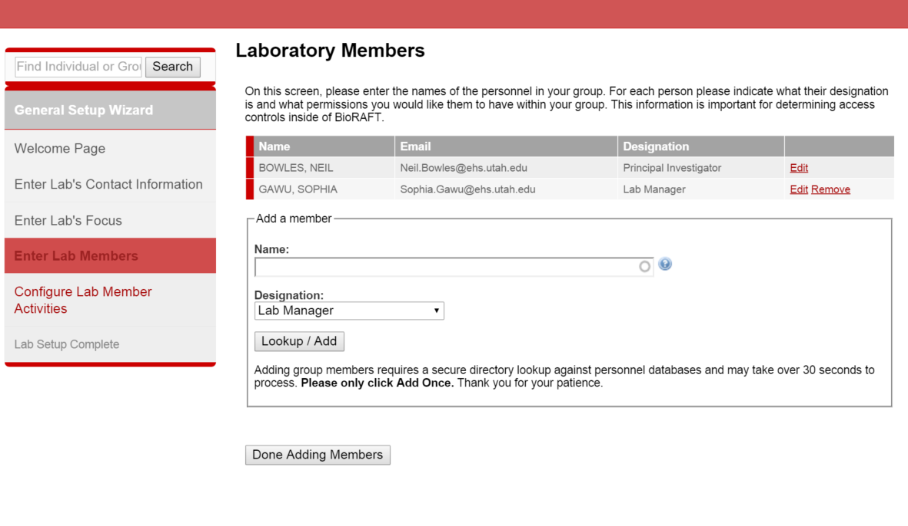
After adding all lab members, click “Done Adding Members.”

- Configure Lab Member Activities
Under each tab; select all applicable job activities that the group members in your lab perform. Note there are 4 tabs to complete (Biological, Animal, Chemical and Radiological). Then click the ‘Submit’ button.

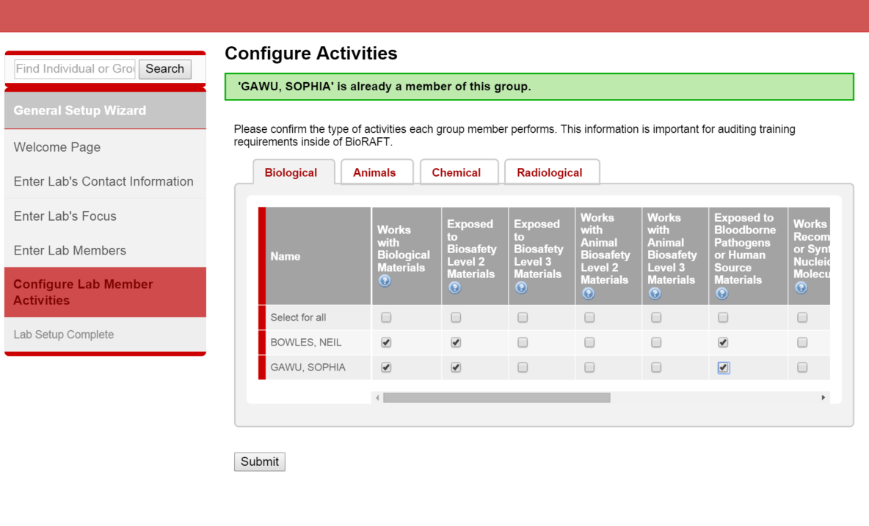

- Laboratory Setup Complete
To finish your General Laboratory Setup and begin your Biological Registration process, click the ‘Continue’ button.
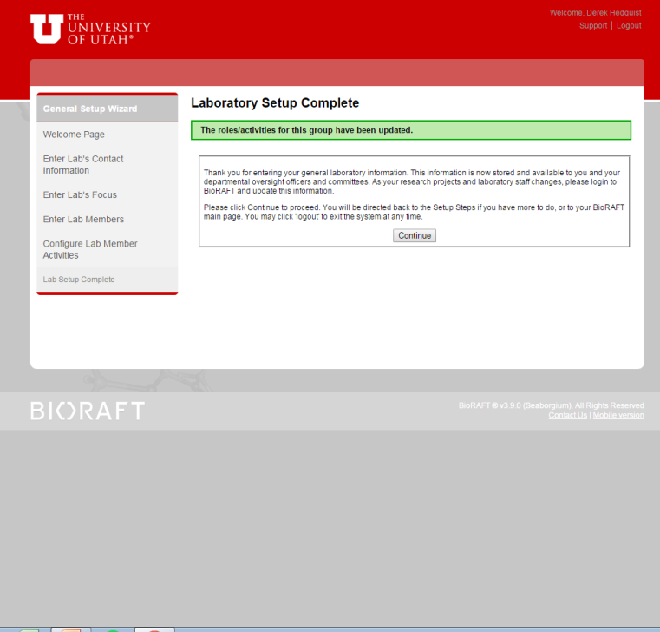

At the University of Utah labs will be defined as:
- Biological labs with non-exempt protocols: these are projects that require registration with the IBC and involve pathogenic agents, materials infected with pathogenic agents (e.g. blood from HIV positive patients), acute biological toxins (http://ehs.utah.edu/research-safety/biosafety/protocol-review/biological-toxins-registration), and/or recombinant or synthetic nucleic acid, as defined in the NIH Guidelines (http://osp.od.nih.gov/sites/default/files/NIH_Guidelines.html).
- Biological labs with exempt protocols: these are projects that do not require registration with the IBC and involve non-pathogenic agents, other biological toxins or recombinant or synthetic nucleic acid molecules considered exempt under Section III-F of the NIH Guidelines (http://osp.od.nih.gov/sites/default/files/NIH_Guidelines.html): also refer to Appendix C of the guidelines (http://osp.od.nih.gov/sites/default/files/NIH_Guidelines.html#_APPENDIX_C._EXEMPTIONS)
- Non-Biological Labs: laboratories that do not work with biological materials.

In order to complete your laboratory Registration, laboratories working with biological agents will need to complete a Biological Registration Wizard. Please visit the University of Utah BioRAFT website (https://ehs.utah.edu/research-safety/biosafety/bioraft) for more information and links to Guides for completing the BioRAFT registration process.

There are no further requirements for Non-biological laboratories.

EHS staff will review the registration and contact you if any changes/clarifications are requested.

BioRAFT will send out an automatic reminder annually to check and re-confirm your laboratory information.

