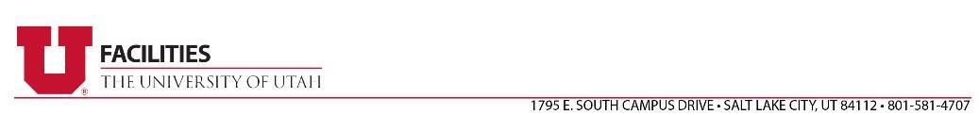

TERMINATION AND DEBARMENT CERTIFICATION

Firm Name: Click or tap here to enter text.

This letter is to certify that the referenced firm or any of its principles, have not been and are not presently debarred, suspended, proposed for debarment, declared ineligible or voluntarily excluded from soliciting work for any government department or agency.

This firm also certifies that neither the firm nor its principles have been terminated during the performance of a contract or have withdrawn from a contract to avoid termination.

Signature:

Title: Click or tap here to enter text.
Date: Click or tap to enter a date.

Department of Public Licensing Number (DOPL), if applicable: Click or tap here to enter text.

