2021-2022 Residence Hall Association
President & Vice President Elections Packet

CONTACT INFORMATION

Questions or Concerns | Who to Contact?
Campaign logistics including: timeline, campaigning, possible violations, policies and procedures, and debate set-up | Elections Registrar  Jenni Schreiner  Asst Dir of Residential Education  jschreiner@housing.utah.edu
Positional questions, positional responsibilities, wondering what it’s like to hold the position, RHA organizational structure, etc. | 2020-2021 Executive Board  Naga Paritala  Current RHA President  u0916966@utah.edu  Sam Dalton  Current RHA Vice President  u1171014@utah.edu
Additional support and questions | RHA Advisors  Joshua Hutchinson  Resident Director - RHA  jhutchinson@housing.utah.edu  Amber Gordon  Area Coordinator  agordon@housing.utah.edu

ELECTIONS TIMELINE

Action | Dates
Recruitment Process Begins | Tuesday, March 2
Intent Due (emailed to jschreiner@housing.utah.edu) | Monday, March 15 at 5pm
Check-in with Advisor (advisor emails availability) | Wednesday-Friday, March 17-19
1-Page Bid & Campaign Advertisements Due  (Physical poster design & Virtual campaign materials) | Tuesday, March 23
Campaigning | March 29-April 7
HRE Meet & Greet | Thursday, April 1
Elections | Monday & Tuesday, April 12-13
Offer & Acceptance | Thursday, April 15
Formal Transition Meeting w/ Advisor (advisor emails availability) | April 21
Timeline to Select Executive Board | April and May

ELIGIBILITY

All RHA members are eligible to run for office who:
- Live in the residence halls as per the contractual agreement with the Housing & Residential Education (HRE), and in good financial standing with HRE and University of Utah.
- Are in good judicial standing with HRE and University of Utah.
- Are in good academic standing with the University of Utah.

COMPENSATION

The RHA President and Vice President for Business & Regional Involvement stipends will be equivalent to three and a half percent (3.5%) of RHA funds collected per semester. When funds permit, HRE will instead provide the equivalent of one-hundred percent (100%) of a Benchmark/Shoreline Three-Person Apartment. The remaining balance will be provided by RHA.

The RHA President and Vice President for Business & Regional Involvement are required to live on-campus during the summer semester beginning their term. During this time, which includes summer stayover, their room is paid for by HRE, but does not include a meal plan.

CAMPAIGN RULES AT A GLANCE

All candidates must obey Section D of the RHA Constitutional By-Laws, which are provided in this packet. Ignorance of these rules or failure to seek clarification from the Elections Registrar will not be a sufficient defense for grievances. A few rules to highlight include:
- No door-to-door solicitation
- The RHA Office and its programs are official “campaign free zones”
- Candidates may not use HRE equipment including printing, posting materials, and any other RHA owned equipment (e.g. popcorn machine, candy, room reservations, etc.)
- Lack of adherence to any University of Utah, HRE, RHA or other policy/regulations regarding the posting of materials, use of facilities, or dissemination of information may result in removal from the RHA Elections process.

LETTER FROM ELECTIONS REGISTRAR

Dear Presidential/Vice Presidential Candidate,

Thank you for expressing interest in 2021-2022 Residence Hall Association (RHA) President and Vice President for Business and Regional Involvement positions. RHA acts as the residential student government charged to make life on-campus feel like home. In these positions, you will lead an executive board in a yearlong journey of advocacy, leadership development, and programming. In the process, you’ll uncover deep lessons about yourself, incomparable professional development, and the opportunity to dramatically impact thousands of lives.

I am here to encourage you along the way, helping to ensure that the elections process is clear and well-structured rather than feeling like a burden. You’ll be surprised by how much you’ll grow just by submitting your name and becoming a candidate. In this packet you will find all of the necessary information for your candidacy for the RHA Presidency or Vice Presidency. I hope this helps clarify any questions, but know that I am here for you and to address your questions or concerns.

Finally, we wanted to share some tips and tricks for success from previous RHA candidates:
- Being President and Vice President means interacting with tons of people who have different wants and needs. Remember that building positive and lasting relationships are foundational to your success.
- Don’t stress the small stuff!
- Follow through is critical- if you say you’ll do something, do it. And if you drop the ball, own it.
- The one page bid should reflect who you are! Be creative, have fun with it, but make sure to include your vision, goals, and what makes you qualified.
- The word “debate” is scary, but it’s really less terrifying in action. Being able to apply and complete this process requires deep reflection about yourself and why you believe in positive residential community. Figure out ways to show that through examples from your life and leadership. There’s never a need to compare yourself to other candidates to seem qualified.
- Have fun! Use every moment of this process as an opportunity to learn about the passion others share for life on campus and to share your authentic self with others.

Best of luck on your journey and thank you again for your interest!

Thank you,

Jenni Schreiner
Elections Registrar

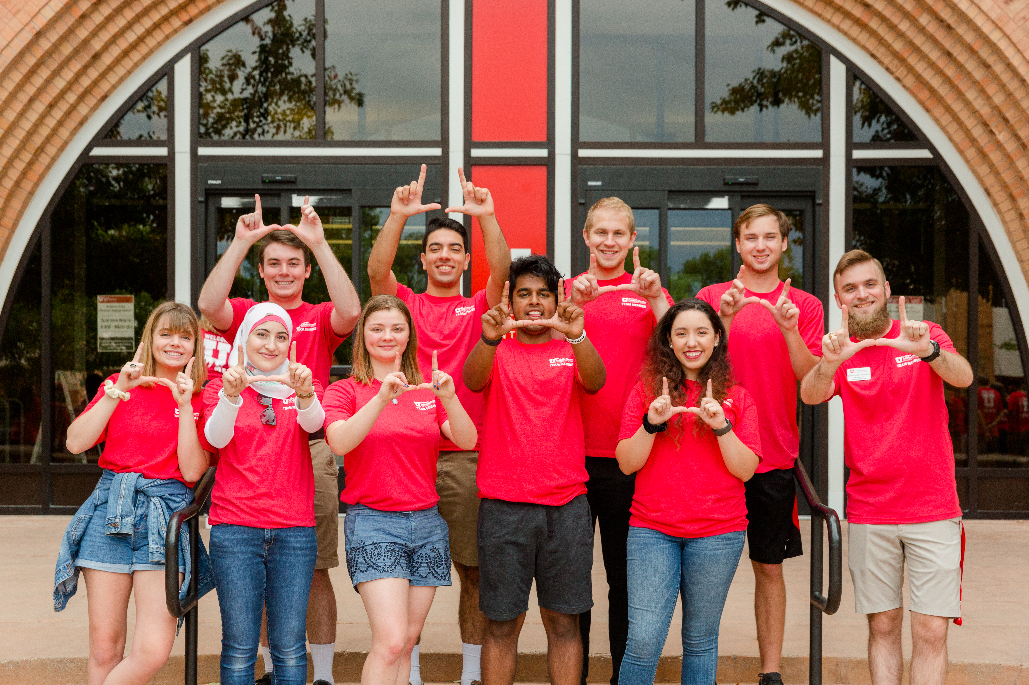

POSITIONAL RESPONSIBILITIES

The RHA President will manage the overarching goals and objectives of the Residence Hall Association in the year of their election. This begins first and foremost with the recruitment, selection, and management of an Executive Board.

In addition to supporting organizational management, the Vice President for Business and Regional Involvement manages regional and national conference attendance as well as administrative needs of RHA. This includes, but is not limited to: budget allocation, budget management, paperwork, etc.

Below are the position descriptions for each provided in the RHA Constitution & Bylaws. Depending on goals and objectives established by the candidate, additional responsibilities may fall under the auspices of these roles.

Section C – RHA Executive Board Positional Responsibilities

1. Residence Hall Association (RHA) President

- Be the Chief Executive Officer of RHA.
- Collaborate with the RHA Advisor, NRHH President, and Vice President of Business and Regional Involvement on the selection process of appointed Executive Board Member
- Chair and set the agenda for all Executive Board meetings.
- Be in charge of Executive Board Member leadership development and morale
- Be responsible for all RHA programs, policies, procedures, and actions.
- Maintain a board member census and conduct a quarterly board member analysis to present to the Executive Board.
- Be responsible for supervising all funds within the RHA Budget with powers to impose special holds, freezes, and initial delegation or allocation of funds in conjunction with the Vice President for Business and regional Involvement and RHA Advisor as well as a simple majority of Executive Board.
- Oversee a budget with the Vice President for Business and Regional Involvement and RHA Advisor each semester to be presented to the Executive Board to be approved by a two-thirds vote of the Executive Board. Serve as a good steward of resident funds.
- Be responsible for signing all RHA Purchase Orders with the Vice President for Business and Regional Involvement and RHA Advisor.
- Be a voting member of the Executive Board only in the event of a tie.
- Form ad hoc committees.
- Co-create and submit, with the Vice President of Business and Regional Involvement and NRHH President, a yearly research or resource paper to the NACURH Information Center in order to maintain affiliated status.
- Serve as the official representative of residents to all organizations, or appoint a designee as appropriate.
- Attend all meetings and serve as a voting member on the University of Utah Union Board.
- Attend the NACURH Conference the first summer of their term and subsequent IACURH regional conferences.
- Be responsible for coordinating Executive Board training, in collaboration with the RHA Advisor, including revision and development of an Executive Board Training Manual
- Reside on campus and serve on the Summer Executive Board at the start of their term
- Attend weekly RHA Presidential Cabinet meeting
- Complete five (5) office hours per week

2. Vice President for Business and Traditions

- Take and make available all executive board minutes to the public.
- Keep and maintain all RHA records for a period of no less than three years.
- Be directly responsible for RHA funds allocated to the Administration and Conference budget.
- Prepare with the RHA President and Advisor a budget each semester that is in alignment with serving as a good steward of the resident’s funds.
- Co-sign with the President and Advisor all RHA Purchase Orders.
- Be responsible for keeping record of the funds allocated to the Executive Board with special regard to actual amounts spent.
- Turn in original receipts and Prize Documentation Forms to Accounts Payable office in Housing & Residential Education (HRE).
- Be responsible for ethical spending of the RHA budget by conducting a Cost per Attendee analysis at the end of every semester for each of the boards.
- Meet with the accounting representative in HRE to reconcile the proposed budget with the actual expenditures on a monthly basis
- Develop a stipend payment memo on a monthly basis to be approved by the RHA President and the RHA Advisor that details the amount to be credited to each RHA Executive Board member on a monthly basis. The memo should be submitted in time to be approved and provided to HRE by the 7th of each month.
- Recruit, select, and prepare a student delegation and conference committee chair(s) for attendance at regional and national conferences in collaboration with the RHA Advisor.
- Create and submit a yearly resource file Index “RFI” report to the NACURH Information Center to maintain affiliated status.
- Attend and represent the University of Utah RHA at NACURH-affiliated conferences.
- Be responsible for all logistical and administrative preparations for NACURH-affiliated conferences.
- Organize and submit monthly RHA updates and case studies to NACURH, or as otherwise required to maintain communication within NACURH.
- The outgoing the incoming NCC(s) shall attend the NACURH Conference.
- Be responsible for all fundraising efforts associated with OCM including the Care Package program and distribution.
- Be responsible for Of The Month submissions to the regional level in the case that the NRHH chapter is unable to fulfill this responsibility.
- Function as the RHA President in the RHA President’s absence.
- Reside on campus and serve on the Summer Executive Board at the start of their term
- Attend weekly RHA Presidential Cabinet Meeting
- Complete five (5) office hours per week.

ELECTION RULES

Section E – Elections Policy and Procedure, 5. Election Rules, b. Campaign Violations
- Campaign violations will consist of but not be limited to: Disturbance of any residence hall floor, building, area, program, or function including accidental, planned, or continued disturbance or distribution of campaign materials under resident’s doors.
- Door to door solicitation.
- The defacing and/or destruction of University or private property.
- The use of bullhorns and windshield obstructions.
- The posting of campaign materials other than as provided by the posting policy.
- A candidate’s interference with another candidates’ campaign, including defacing or destruction of another’s property.
- Any active campaigning in the RHA offices. This will include the use of RHA materials and equipment.
- The lack of adherence to any University, HRE, RHA, or other regulations regarding the posting of materials, use of facilities or dissemination of information.
- Any student will have the opportunity, upon submission of a formal written complaint, to have his/her complaint heard before the Elections Registrar. All complaints must be submitted by noon on the day following the closing of the polls for the final election.
- Election results will not be announced until all grievances and appeals have been acted upon by the Elections Registrars, including all fines paid. Fines not paid by the deadline set by the Elections Registrar will result in candidate disqualification.
- The Elections Registrars will have discretion in taking disciplinary action appropriate for violations, which sanctions will include but not be limited to removal from the ballot, forfeiture of the right to office, or fines. No sanction will be imposed for a period to exceed one (1) academic year.

ADVISOR CHECK-IN

All functions of the Residence Hall Association are advised by professionals in Housing & Residential Education. While this is a student run organization, advisors provide critical support to the success of RHA in many ways, including financial literacy, institutional knowledge, risk management, personnel expertise, historical contexts, and departmental buy-in. As such, all candidates will meet with an RHA organizational advisor as part of their election bid to learn more about the role and clarify goals. Be prepared to discuss the following:

- One of RHA’s five goals is advocacy: strategizing and implementing change to improve the residential student experience. What changes to HRE or RHA do you believe will improve the student experience and what steps would you take to implement those changes?
- The RHA President and Vice President for Business & Regional Involvement work together to manage an Executive Board consisting of six directors. What skills will you employ to support your directors while holding them accountable to their constitutional responsibilities?
- RHA Boards are made up of residents living in all communities of Housing & Residential Education. What recruitment strategies do you believe will be most successful and how will you support Executive Board members in recruiting and retaining members?
- Approximately 1200 residents live on campus over the summer. What events will you provide for these residents?
- The RHA Executive Board hosts large scale events during move-in weekend in August. What strategies will you use to ensure students are excited about life on campus and get connected to RHA?

POSTER & CAMPAIGNING

President & Vice President candidates develop a 1-Page Poster as a departmentally-approved marketing material. RHA will print an equal number of these 8.5 x 11 posters for use as campaign materials, which can be hung or handed out. Candidates must oblige by campaign rules discussed in this packet. Candidates must work with RHA Advisors or Elections Registrar to discuss the plausibility of other campaign strategies.

CANDIDATE MEET & GREET

To maintain distance and safety for the 2021-2022 election, all campaigning will be done virtually. In addition to the posters you create, the Elections Registrar will create a platform poster to allow residents to see candidates and their stance on the issue. These posters will be hung in dining and/or lobby areas of public spaces. Posters will be hung for at least a week during the campaign period. Due to contact restrictions, this is an additional opportunity for candidates to share their platform directly with current residents. After submitting a 1-page bid, the Elections Registrar will send candidates a document to answer three questions about their platform in 100-words or less.

To maintain distance and safety for the 2021-2022 election, RHA and the Elections Registrar will host a virtual Meet & Greet with members of Housing & Residential Education (HRE) staff. This is a time for professional staff members to ask about your plans and hopes for the upcoming year. This conversation will occur on Thursday, April 1 via Zoom.

2021-2022 Residence Hall Association
President and Vice President for Business & Regional Involvement
Candidate Intent Form

Return this form via email to Jenni Schreiner at jschreiner@housing.utah.edu
no later than Thursday, March 15, 2021 at 5pm

Name: _________________________________________________________
Student ID #:____________________________________________________
Email: _________________________________________________________
Cell Phone: _____________________________________________________
I intend to run for: ____ RHA President ____ Vice President for Business

I understand that by signing this application, I agree to all the policies and procedures of campaigning.

I understand that I am responsible for all information provided in this packet and that it is my responsibility to reach out to the Elections Registrar prior to taking uncertain action.

I understand that by signing this application, I am giving permission to Housing & Residential Education to access my academic and disciplinary records.

I understand that successful candidates for the 2021-2022 RHA Presidential positions are intended to hold the position for one year, beginning in Summer 2021 and continuing to the end of Spring 2022. I understand that it is my responsibility to remain in good financial, academic, and disciplinary standing throughout the term of office.

Candidate Signature: _________________________________________ Date: ___________

